Pune District Education Association’s
Seth Govind Raghunath Sable College of Pharmacy, Saswad
&
Pune District Education Association’s
Seth Govind Raghunath Sable College of Pharmacy (Poly.), Saswad
Joint activity Participation
Activity Report
Title of the event: Seminar on “National Education Policy 2020”
Name of activity: Faculty Development Programme
Date and Day: 31/08/2023 Thursday Time: 02:30 pm to 04:00pm
Higher education plays an extremely important role in promoting human as well as societal wellbeing and in development of India. We all know that changed new educational policy is based on four pillars which are Access, Equity, Quality, and Accountability. The features of NEP, however we are still in predicament that how is it going to work, The kind of changes will be imposed as per this new educational system and the challenges and preparedness for NEP, the future of teacher as per this policy. In this view one day Faculty Development Programme for our faculty members on topic “National Education Policy 2020” has been organized by the on 31st August 2023 at 02:30 pm. Dr. Remeth Dias Govt.college of pharmacy Karad gave valuable guidance on NEP. Our faculty members are greatly benefited and are sensitized from your views and guidelines.
The program ended with a vote of thanks by Ms. Smita Deshmukh. The activity conducted under the guidance of Dr. Smita Pawar Vice- Principal and Dr. R.S. Chavan Principal.

Mrs.S.M.Deshmukh Dr. Rajashree Chavan

Photo Gallery (Faculty Development Program) 31/08/2023

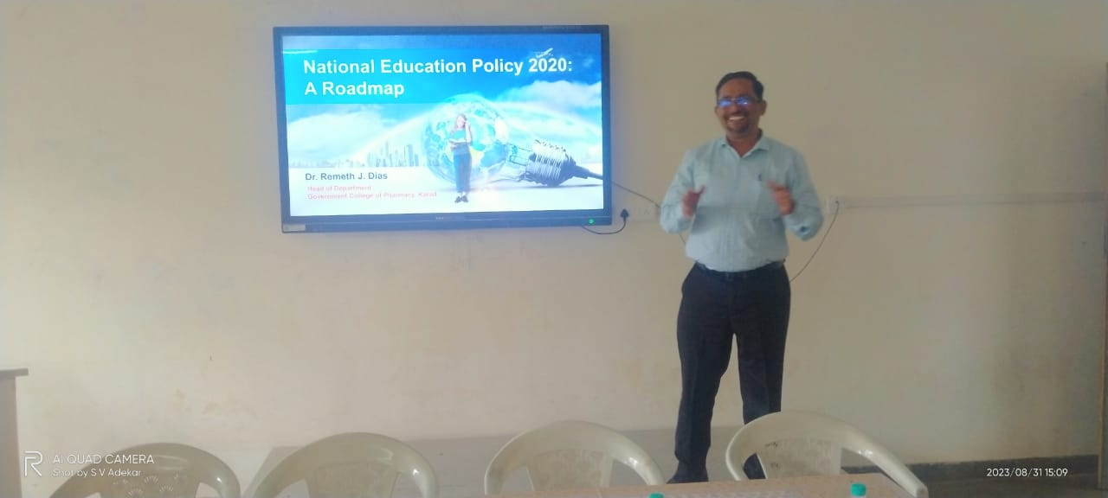

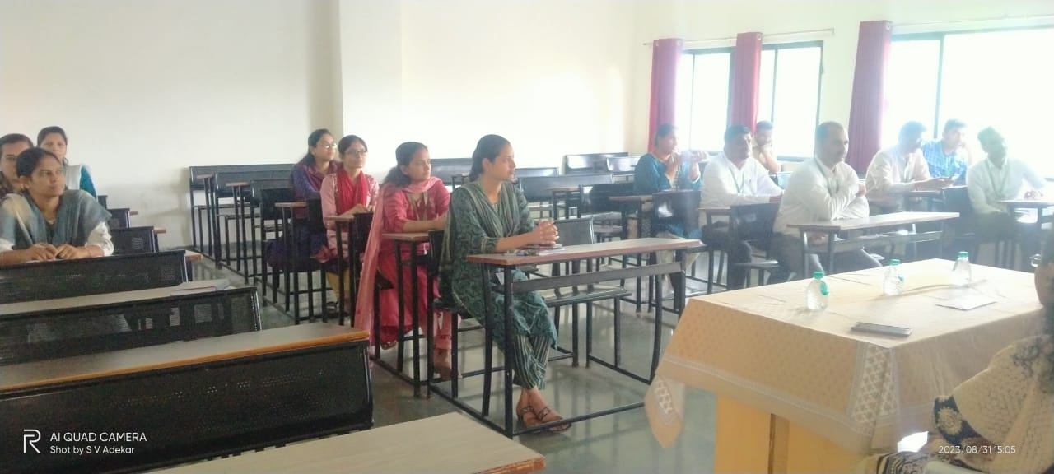
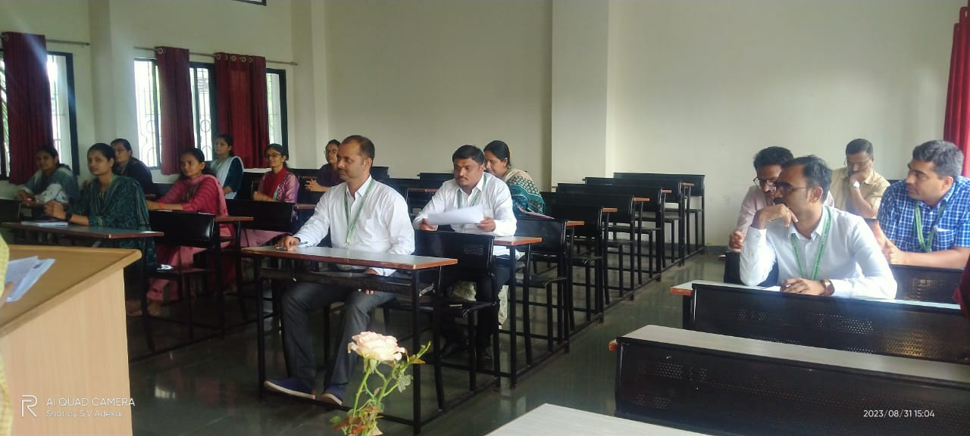

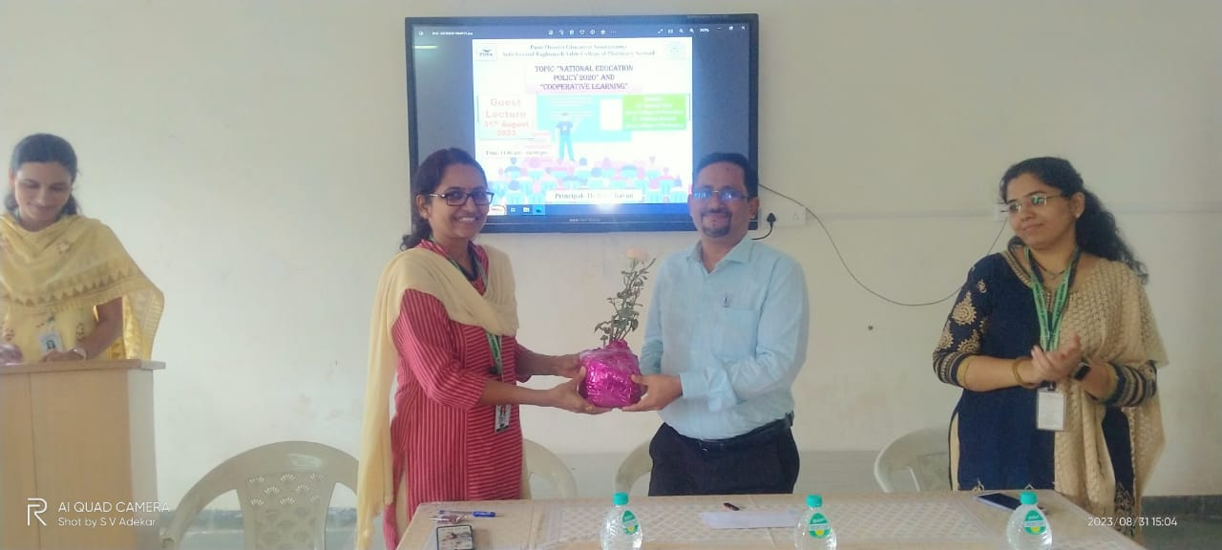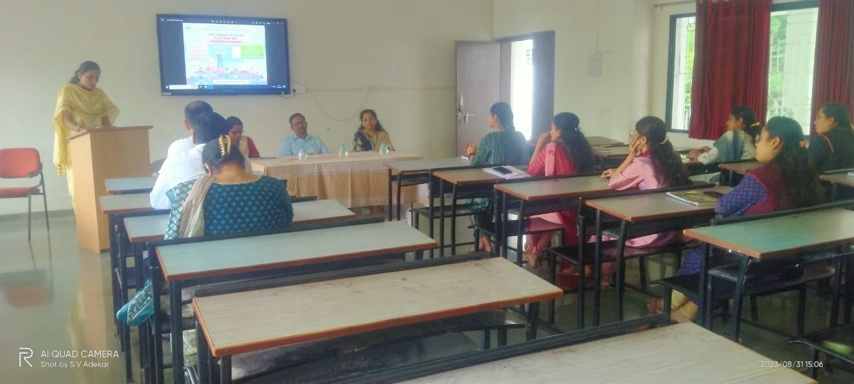
Dr. Rajashree Chavan
Principal

